|  |  |  |
| --- | --- | --- |
| **Question 1** |  | 1 / 1 point |

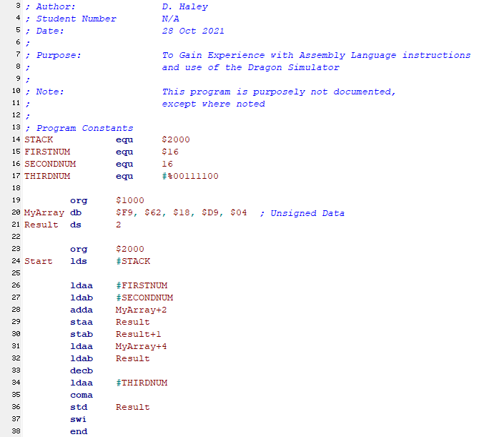  
   
Example Questions & Answers (to illustrate the Format for your answers – e.g. use of "$" and "%" signs):  
After the execution of line 24, what is the 16-bit HEX value in SP? Answer: **$2000**  
After the execution of line 26, what is the 8-bit HEX value in Accumulator A? Answer: **$16**  
After the execution of line 26, what is the 8-bit BINARY value in Accumulator A? Answer: **%00010110**  
Note that 8-bit HEX values should be capitalized – e.g. use $3B versus $3b  
--------------------------------------------------------------------  
The following questions refer to the above code listing.  
  
After the execution of line 26, what is the 16-bit HEX value in PC?

|  |  |  |
| --- | --- | --- |
| Answer: | $2005 |  |
| **Question 2** | | |  | 1 / 1 point |

After the execution of line 27, what is the 8-bit HEX value in Accumulator B?

|  |  |  |
| --- | --- | --- |
| Answer: | $10 |  |
| **Question 3** | | |  | 1 / 1 point |

After the execution of line 28, what is the 8-bit HEX value in Accumulator A?

|  |  |  |
| --- | --- | --- |
| Answer: | $2E |  |
| **Question 4** | | |  | 1 / 1 point |

After the execution of line 29, the contents of A are stored in what 16-bit HEX address?

|  |  |  |
| --- | --- | --- |
| Answer: | $1005 |  |
| **Question 5** | | |  | 1 / 1 point |

After the execution of line 31, what is the 8-bit HEX value in Accumulator A?

|  |  |  |
| --- | --- | --- |
| Answer: | $04 |  |
| **Question 6** | | |  | 0 / 1 point |

After the execution of line 32, what is the 8-bit BINARY value in Accumulator B?

|  |  |  |
| --- | --- | --- |
| Answer: | %00101110 | Incorrect Response**(%00111110)** |
| **Question 7** | | |  | 1 / 1 point |

After the execution of line 35, what is the 8-bit BINARY value in Accumulator A?

|  |  |  |
| --- | --- | --- |
| Answer: | %11000011 |  |
| **Question 8** | | |  | 1 / 1 point |

After the execution of line 36, what is the 16-bit HEX value in PC?

|  |  |  |
| --- | --- | --- |
| Answer: | $201D |  |
| **Question 9** | | |  | 0 / 1 point |

What is the opcode (object code) for the instruction in line 33?

|  |  |  |
| --- | --- | --- |
| Answer: | 53 | Incorrect Response**($41)** |
| **Question 10** | | |  | 1 / 1 point |

What is the three letter abbreviation for the Addressing mode of the instruction used in line 37?

|  |  |  |
| --- | --- | --- |
| Answer: | INH |  |

Created by Respondus

|  |  |  |
| --- | --- | --- |
| **Question 11** |  | 9 / 15 points |

Match the following Required Operations with the Correct Line of Code, noting that that there are more available answers than there are questions.  
Example: "Loads Accumulator A with the HEX value of 18." That line of code would be ldaa #$18. You would then search the right hand column for that answer – e.g. 42. ldaa #$18, then select 42 from the drop down menu for "Load Accumulator A with the HEX value of 18."

|  |  |  |  |  |  |  |  |  |  |  |  |  |  |  |  |  |  |  |  |  |  |  |  |  |  |  |  |  |  |  |  |  |  |  |  |  |  |  |  |  |  |  |  |  |  |  |  |  |  |  |  |  |  |  |  |  |  |  |  |  |  |  |  |  |  |  |  |  |  |  |  |  |  |  |  |  |  |  |  |  |  |  |  |  |  |  |  |  |  |  |  |  |  |  |  |  |  |  |  |  |  |  |  |  |  |  |  |  |  |  |  |  |  |  |
| --- | --- | --- | --- | --- | --- | --- | --- | --- | --- | --- | --- | --- | --- | --- | --- | --- | --- | --- | --- | --- | --- | --- | --- | --- | --- | --- | --- | --- | --- | --- | --- | --- | --- | --- | --- | --- | --- | --- | --- | --- | --- | --- | --- | --- | --- | --- | --- | --- | --- | --- | --- | --- | --- | --- | --- | --- | --- | --- | --- | --- | --- | --- | --- | --- | --- | --- | --- | --- | --- | --- | --- | --- | --- | --- | --- | --- | --- | --- | --- | --- | --- | --- | --- | --- | --- | --- | --- | --- | --- | --- | --- | --- | --- | --- | --- | --- | --- | --- | --- | --- | --- | --- | --- | --- | --- | --- | --- | --- | --- | --- | --- | --- | --- | --- |
| |  |  |  |  | | --- | --- | --- | --- | | Incorrect Response | __16__ | **(4)** | Loads Y with the contents of Memory Address $1E12 | |  | __8__ |  | Logically shifts Accumulator A to the Left | |  | __15__ |  | Loads B with the contents of Memory Address $101A | |  | __6__ |  | Transfers X to Y | |  | __13__ |  | Compares A to B | |  | __2__ |  | Adds Accumulator B to Accumulator A | | Incorrect Response | __25__ | **(14)** | Points Y to Memory Address $1200 | | Incorrect Response | __24__ | **(7)** | Adds B with the contents of Memory Address $101A | |  | __10__ |  | Subtracts B from A | | Incorrect Response | __17__ | **(3)** | Points X to the Memory Address designated by the Label Array1 | |  | __12__ |  | Adjusts Sum in Accumulator A to BCD | | Incorrect Response | __20__ | **(9)** | Loads X with the contents of the Memory Address designated by the Label Source | |  | __1__ |  | Stores D to Memory Address $102F | |  | __11__ |  | Exchanges Y and X | | Incorrect Response | __19__ | **(5)** | loads A with the contents of Memory Address $201A | |  | |  |  | | --- | --- | | **1**. | std $102F | | **2**. | aba | | **3**. | ldx #Array1 | | **4**. | ldy $1E12 | | **5**. | ldaa $201A | | **6**. | tfr x,y | | **7**. | addb $101A | | **8**. | lsla | | **9**. | ldx Source | | **10**. | sba | | **11**. | exg y,x | | **12**. | daa | | **13**. | cba | | **14**. | ldy #$1200 | | **15**. | ldab $101A | | **16**. | ldy #$1E12 | | **17**. | ldx Array1 | | **18**. | cab | | **19**. | ldaa #$201A | | **20**. | ldx #Source | | **21**. | staa #201A | | **22**. | sab | | **23**. | lsra | | **24**. | ldab #$101A | | **25**. | ldy $1200 | | **26**. | tra x,y | |
|  |  | |